General Description
Coombe Farm is less than two miles from Croydon town centre, yet is set in quite rural surroundings: it is just on the edge of Lloyd Park and close to the Addington Hills, an area of natural beauty, with scope for interesting walks and many other activities. The site consists of about 3 acres of enclosed campsite: the lower end is ideal for Patrol Camping and the upper field is suitable for games and camp activities. Coombe Farm may be hired by members of nationally recognised organisations provided they have Third Party insurance cover and are accompanied by responsible adult leaders.

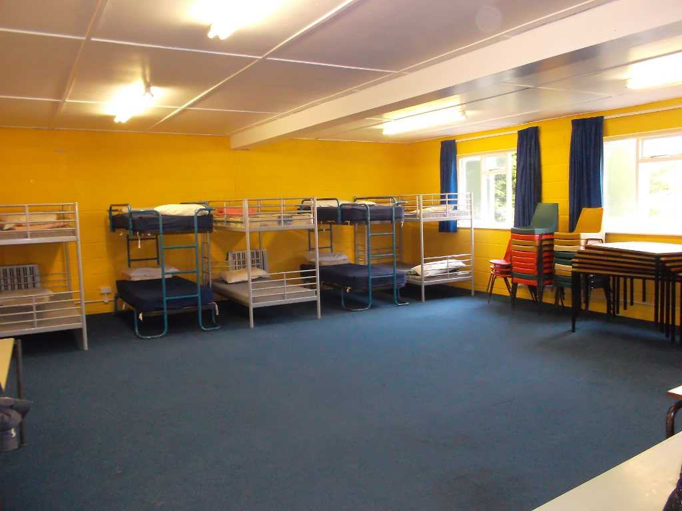
The Chris Coxon Training Centre
The centre is available for indoor camps, Pack Holidays, Beaver sleepovers and Training Courses. The main room is 30’ x 30’ and there is a well equipped modern kitchen. The main room has 5 bunk beds (sleeping 10), and an adjoined room that can sleep 4. A further room next to the toilet block can sleep 6. Users of the Training Centre will need to provide their own pillow cases and sleeping bags. The Centre is a non-smoking area.

Toilets and Water
The male and female toilets each contain a shower and two wash basins (with hot and cold running water) and two WC's. No cooking or eating equipment should be washed in the toilet block. At the bottom of the slope just under the building is a standpipe for those camping on the field. The water mains stop valve is in the Ladies’ toilet and must be turned off when you leave – in cold weather please also drain cisterns to avoid freezing problems. We ask that you use the water wisely as it is metered.

Electricity
The electricity mains switch is behind the door of the Scouters room. Electric must be switched off before leaving. You will be charged for each unit, and we ask that you take a note of the meter reading upon arrival and departure (please only read the first four numbers on the meter).

Parking
Parking is available inside the gates of the campsite and in the lane, but do not obstruct other vehicles. You may remove the bollard from the path but please remember to replace and lock it after you have parked to avoid other vehicles using the track.

Out of Bounds Areas
The sports field near the site and the greens of the nearby golf course are out of bounds, although the public paths may be used.

Safety
Please discourage climbing on the Chalk cliff and adjacent slope in the quarry. The top edge of the cliff is dangerous and is out of bounds. Take care when going down the steps into the quarry – they are slippery in wet weather.

Fires
Fires should only be lit in the two existing fire sites, one on the top field, and one in the quarry. Also two alter fires are provided and should be cleared afterwards. Care should be taken in hot weather.

Firewood
There is ample wood for fires on the site, but please do not waste it. The cutting of trees, live or dead, is forbidden without permission of the Camp Site Warden.
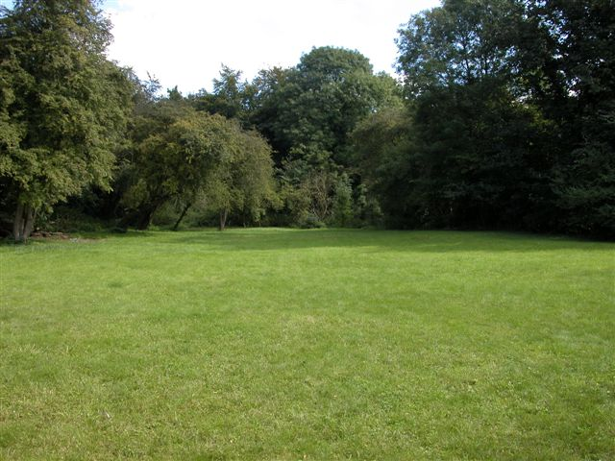
Wet or Dry Pits
These are not allowed as they encourage the animals to dig up the campsite.

Rubbish
Should be bagged up and taken with you. No rubbish should be left in the building when you leave. A compost heap is available at the north end of the site, for any biodegradable rubbish.

Noise
Please keep noise to a minimum late at night, as people do live in the neighbouring buildings.

Security
Please make sure that windows and doors are secured, and all doors and gates are locked when you leave the site or if the building is left unattended at any time.

When you leave
Please leave the campsite, including the buildings, clean and tidy, as you would wish to find them. Please also ensure that the doors of the fridge and the freezer are left open and the water and electricity are turned off.

Medical Information
Casualty: Mayday Hospital, Mayday Road Thornton Heath. 020 8401 3000
Doctor: Dr McCrea & Partners, 59 Addiscombe Road, Croydon, Surrey, CR0 6SD. 020 8688 1213
Each group using the campsite must bring their own first-aid kit.

Churches
C of E: St Mary Magdalene with St Martin, Canning Road, Addiscombe, Croydon, CR0 6QD. 020 8654 3459
R.C.: Our Lady of the Annunciation, Bingham Road, Addiscombe, Croydon, CR0 7EN. 020 8654 1709

Charges
Indoors: Chris Coxon Training Centre: (up to twenty people, with an additional charge of £1.50 per person per night if more than twenty people): £60 per night
Friday to Sunday (18:00h - 18:00h): £120
Daily charge (09:00h - 18:00h): £40
Camp Fees: £2.00 per head per night
Day Visitors: £1.00 per person
(There also is a charge for electricity of 30p per unit consumed)

A deposit of £50 is required at the time of booking: hirers will be expected to pay for any damage to be made good. Cheques made payable to City of Westminster District Scout Council.

Further Information
For general information and booking please contact the camp site warden:
Philip Green, 159 Gladstone Park Gardens, Dollis Hill, London NW2 6RN
020 8830 5223
Mobile: 07816 453 221
phillip.green@gmail.com

